**DAYANANDA SAGAR COLLEGE OF ENGINEERING**

(An Autonomous Institute affiliated to VTU, Belagavi, Approved by AICTE & ISO 9001:2008 Certified)

Accredited by National Assessment & Accreditation Council (NAAC) with ‘A’ grade, Shavige Malleshwara Hills, Kumaraswamy Layout, Bengaluru-560078.

**Minor Project Report**

**on**

**“Entire College Network RIP Protocol And Secure Login Mechanism”**

Submitted By

Priyanshu Raj – 1DS20CS156

Prutha Vasisht – 1DS20CS157

Punith Kumar – 1DS20CS158

**Fifth Semester B.E (CSE)**

**in**

**Computer Networks**

**19CS5DLCNL**

Under the guidance of

**Dr. Nagaraja J.**

**Associate Professor**

**Dept. of CSE**

**DSCE, Bangalore**

**CONTENTS**

|  |  |  |
| --- | --- | --- |
| **SL No.** | **Contents** | **Page No.** |
| 1. | Abstraction | 03 |
| 2. | Introduction | 04 |
| 3. | Design and Configuration | 05-12 |
| 4. | Topology | 13 |
| 5. | Results | 14-15 |
| 6. | Conclusion and Future Enhancement | 16 |

**ABSTRACT**

The goal of this project is to design and implement a secure network using the Routing Information Protocol (RIP) for routing packets between devices.

RIP is a simple distance-vector routing protocol that is widely used in small to medium-sized networks. It allows devices to exchange routing information with each other and to determine the best path for forwarding packets to their destination.

In this project, a network of devices is set up using a variety of hardware and software tools, including routers, switches, and network simulation software. Configuration of each device to use RIP for routing and implement a secure login mechanism to protect against unauthorized access to the network.

The network is tested to ensure that it is functioning correctly and that the secure login mechanism is effective in preventing unauthorized access.

**INTRODUCTION**

A routing protocol specifies how routers communicate with each other to distribute information that enables them to select routes between any two nodes on a computer network.

Dynamic Routing Protocol is used for the communication between the networks. Dynamic Routing Protocol makes automatic adjustment of the routes according to the current state of the route in the Routing table.

The following servers have been used in the project.

DHCP – Each network has DHCP server to assign IP among the devices within the network.

DNS - is specifically used for matching website hostnames to their corresponding Internet Protocol or IP addresses. The DNS server contains a database of public IP addresses and their corresponding domain names.

Web server (HTTP) – Is used to connect to [www.dsce.com](http://www.dsce.com) website.

The network address of each of the subnets is:

CSE – 180.100.20.0

ECE – 180.100.24.0

Mech – 180.100.28.0

Civil – 180.100.32.0

EEE – 180.100.36.0

Library – 180.100.8.0

Reception – 180.100.4.0

Hostel – 180.100.12.0

Server room – 180.100.252.0

Administrator – 180.100.0.0

**DESIGN AND CONFIGURATION**

Number of networks required:64

Ip Address:180.100.0.0 (Class B)

Subnetting is done in this Ip for 64 networks.

1. Number of if 64 = 26

Hence 6 bits are borrowed from the host.

1. Calculating new subnet mask

Old subnet mask = 255.255.0.0

New Subnet Mask = 11111111.11111111.11111100.00000000

i.e., 255.255.252.0

1. Block size:

210 = 1024 bits

|  |  |  |
| --- | --- | --- |
| **Network Ip** | **Valid Range** | **Broadcast Ip** |
| 180.100.0.0 | 180.100.0.1-180.100.3.254 | 180.100.3.255 |
| 180.100.4.0 | 180.100.4.1-180.100.7.254 | 180.100.7.255 |
| 180.100.8.0 | 180.100.8.1-180.100.11.254 | 180.100.11.255 |
| 180.100.12.0 | 180.100.12.1-180.100.14.254 | 180.100.15.255 |
| 180.100.16.0 | 180.100.16.1-180.100.17.254 | 180.100.19.255 |
| 180.100.20.0 | 180.100.20.1-180.100.20.254 | 180.100.23.255 |
| 180.100.24.0 | 180.100.24.1-180.100.23.254 | 180.100.27.255 |
| 180.100.28.0 | 180.100.28.1-180.100.26.254 | 180.100.31.255 |
| 180.100.32.0 | 180.100.32.1-180.100.29.254 | 180.100.35.255 |
| 180.100.36.0 | 180.100.36.1-180.100.32.254 | 180.100.39.255 |
| 180.100.100.0 | 180.100.100.1-180.100.103.254 | 180.100.103.255 |
| 180.100.104.0 | 180.100.104.1-180.100.107.254 | 180.100.107.255 |
| 180.100.108.0 | 180.100.108.1-180.100.111.254 | 180.100.111.255 |
| 180.100.112.0 | 180.100.112.1-180.100.115.254 | 180.100.115.255 |
| 180.100.116.0 | 180.100.116.1-180.100.119.254 | 180.100.119.255 |
| 180.100.120.0 | 180.100.120.1-180.100.123.254 | 180.100.123.255 |
| 180.100.124.0 | 180.100.124.1-180.100.127.254 | 180.100.127.255 |
| 180.100.128.0 | 180.100.128.1-180.100.131.254 | 180.100.131.255 |
| 180.100.132.0 | 180.100.132.1-180.100.135.254 | 180.100.135.255 |
| 180.100.136.0 | 180.100.136.1-180.100.139.254 | 180.100.139.255 |
| 180.100.140.0 | 180.100.140.1-180.100.143.254 | 180.100.143.255 |
| 180.100.144.0 | 180.100.144.1-180.100.147.254 | 180.100.147.255 |
| 180.100.252.0 | 180.100.252.1-180.100.255.254 | 180.100.255.255 |

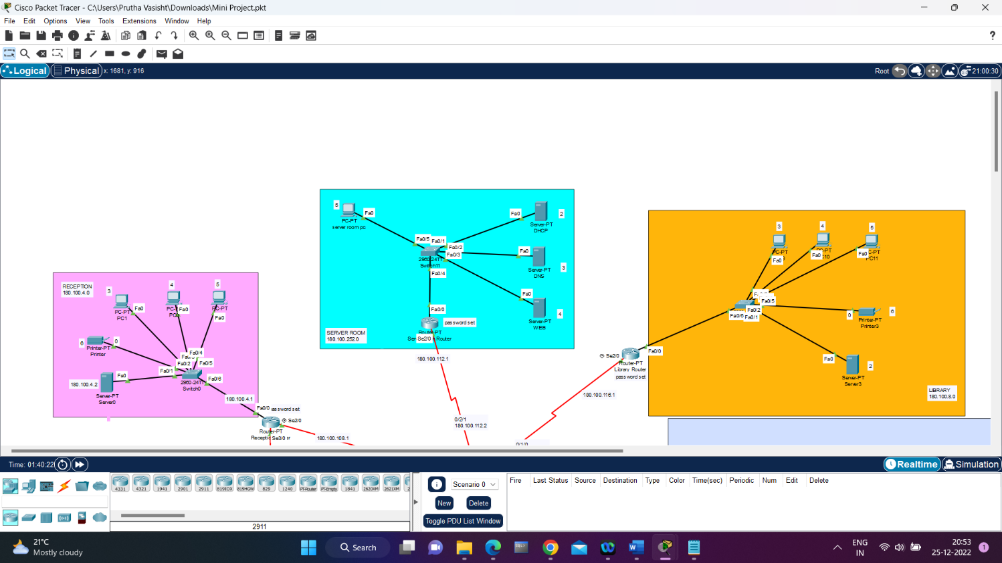

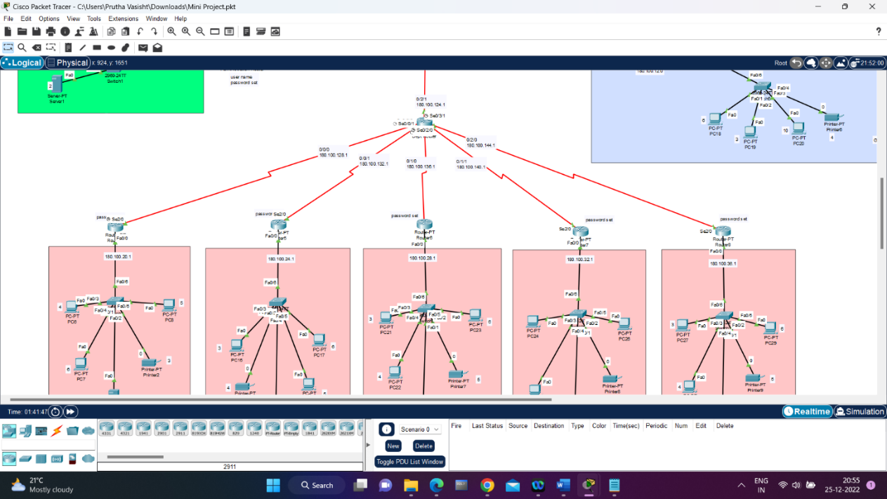

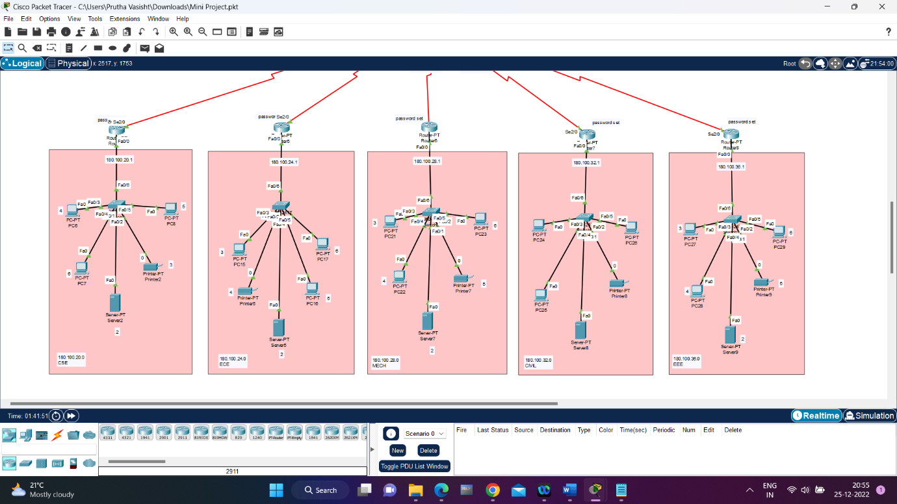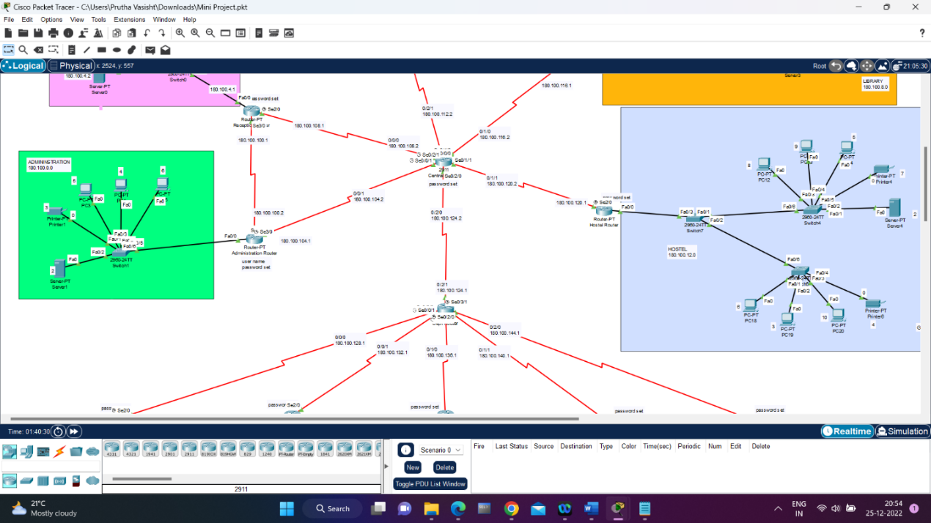 **RIP HEADER FORMAT**

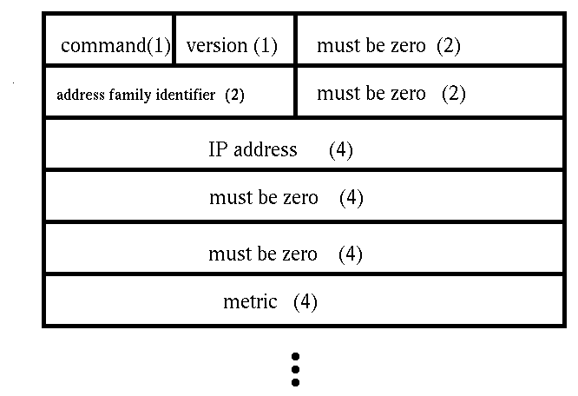

**SECURING ROUTER WITH PASSWORD**

**ADMINISTRATOR**

Router>enable

Router#configuration terminal

Router(config)#line console 0

Router(config-line)#login local

Router(config-line)#exit

Router(config)#username admin password admin

Router(config)#exit

Router#

Router>enable

Router#configuration terminal

Router(config)#enable password admin

Router(config)#

Router(config)#exit

Router#

**CENTRAL ROUTER**

Router>enable

Router#configuration terminal

Router(config)#line console 0

Router(config-line)#login local

Router(config-line)#exit

Router(config)#username admin password admin

Router(config)#exit

Router>enable

Router#configuration terminal

Router(config)#enable password admin

Router(config)#

Router(config)#exit

Router#

**SERVER ROUTER**

Router>

Router>enable

Router#configuration terminal

Router(config)#enable password server

Router(config)#exit

Router#

**HOSTEL ROUTER**

Router>enable

Router#configuration terminal

Router(config)#enable password hostel

Router(config)#exit

Router#

**LIBRARY ROUTER**

Router>

Router>enable

Router#configuration terminal

Router(config)#enable password library

Router(config)#exit

Router#

**RECEPTION ROUTER**

Router>

Router>enable

Router#configuration terminal

Router(config)#enable password reception

Router(config)#exit

Router#

**CSE ROUTER**

Router>

Router>enable

Router#configuration terminal

Router(config)#enable password cse

Router(config)#exit

Router#

**ECE ROUTER**

Router>

Router>enable

Router#configuration terminal

Router(config)#enable password ece

Router(config)#exit

Router#

**MECH ROUTER**

Router>

Router>enable

Router#configuration terminal

Router(config)#enable password mech

Router(config)#exit

Router#

**CIVIL ROUTER**

Router>

Router>enable

Router#configuration terminal

Router(config)#enable password civil

Router(config)#exit

Router#

**EEE ROUTER**

Router>

Router>enable

Router#configuration terminal

Router(config)#enable password eee

Router(config)#exit

Router#

**ROUTER CONFIGURATION**

User Access Verification

Username: admin

Password:

Router>enable

Password:

Router#configure terminal

Router(config)#interface Serial0/0/0

Router(config-if)#ip address 180.100.108.1 255.255.252.0

Router(config-if)#no shutdown

Router(config-if)#

**RIP CONFIGURATION IN EVERY ROUTER**

Router>enable

Router#configure terminal

Router(config)#router rip

Router(config-router)#network 180.100.0.0

Router(config-router)#exit

Router(config)#exit

Router#

**TOPOLOGY**

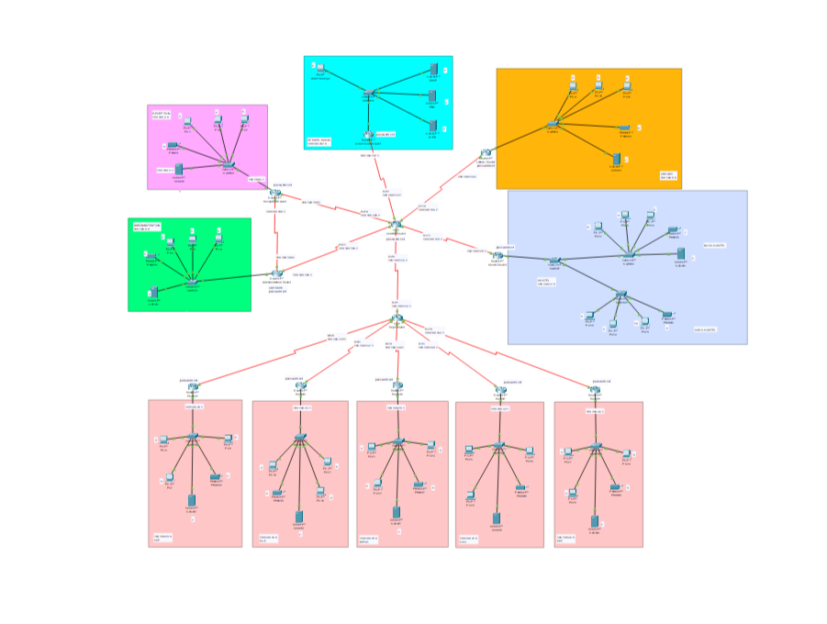

**RESULTS**

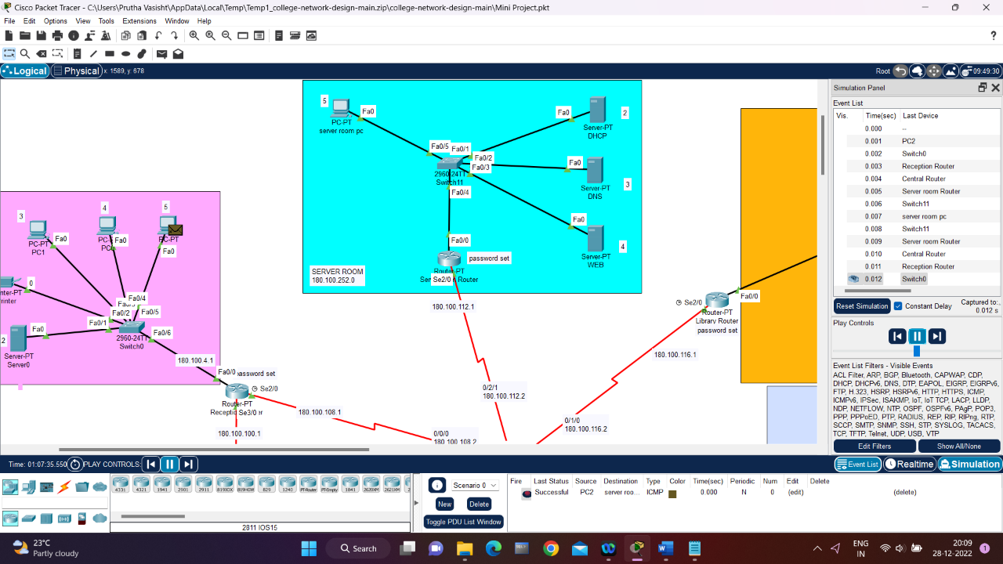

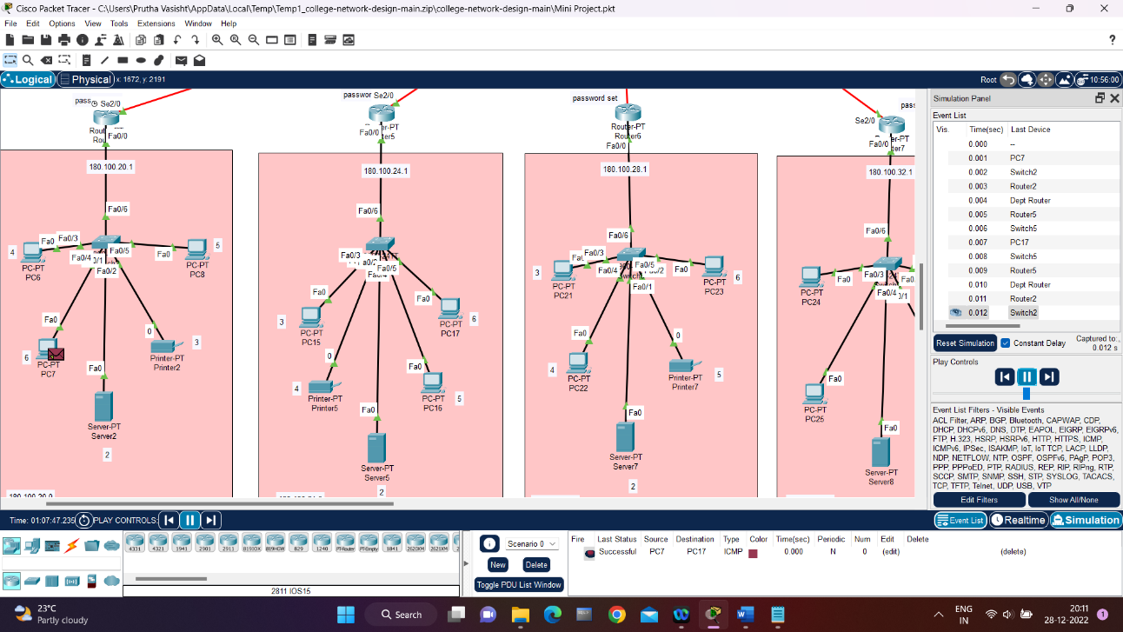

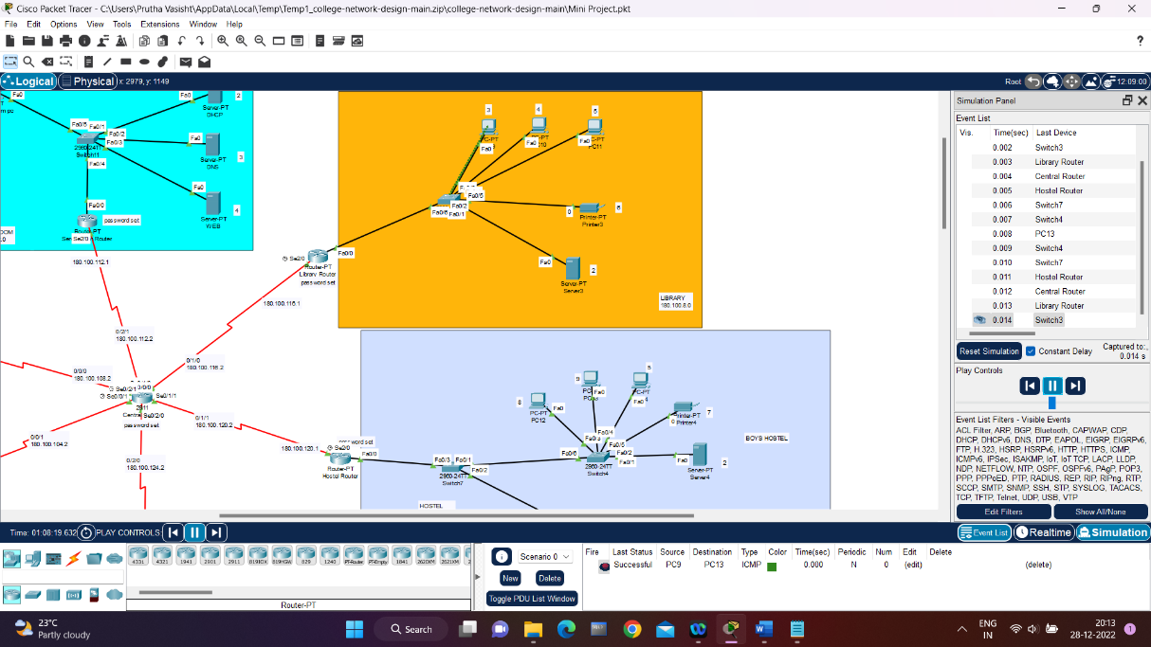

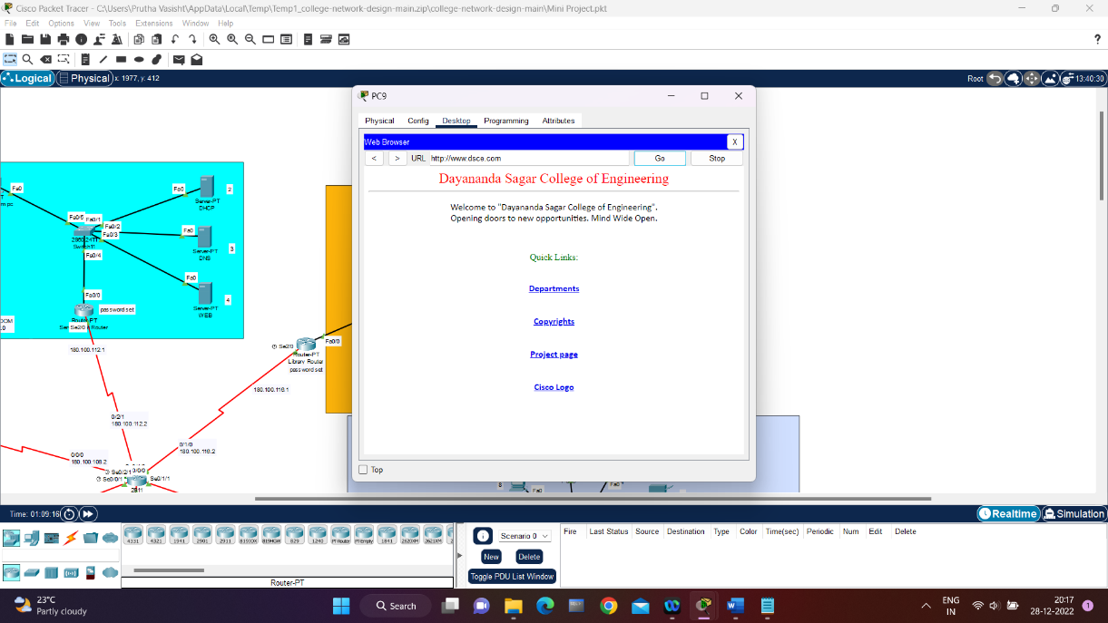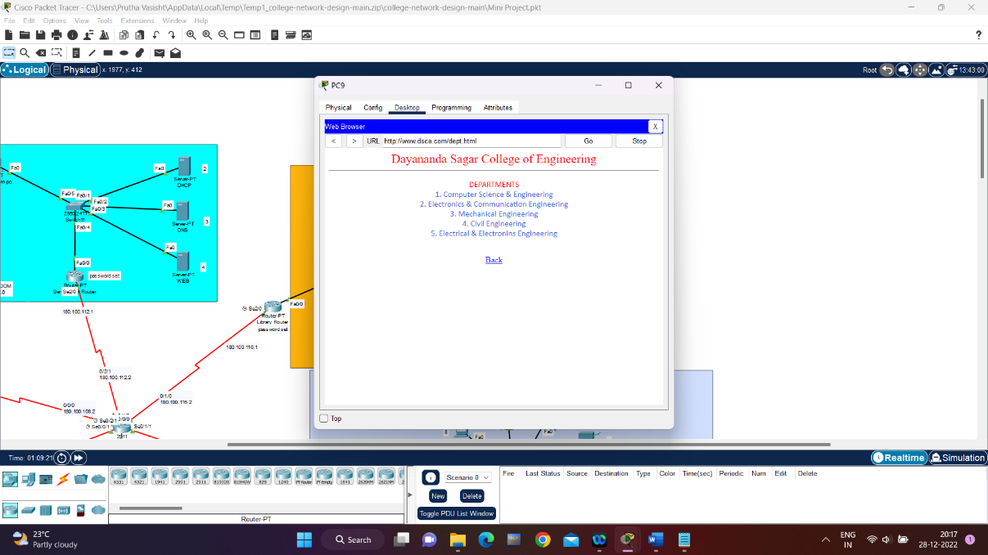

**CONCLUSION AND FUTURE ENHANCEMENT**

In conclusion, the Routing Information Protocol (RIP) can be a suitable choice for a college network due to its simplicity and widespread support. However, there are several potential enhancements that could be made to improve the performance and security of the network. These include using a different routing protocol, enabling route filtering and multicast support, and enhancing convergence. Ultimately, the most appropriate enhancements will depend on the specific needs and requirements of the college network.